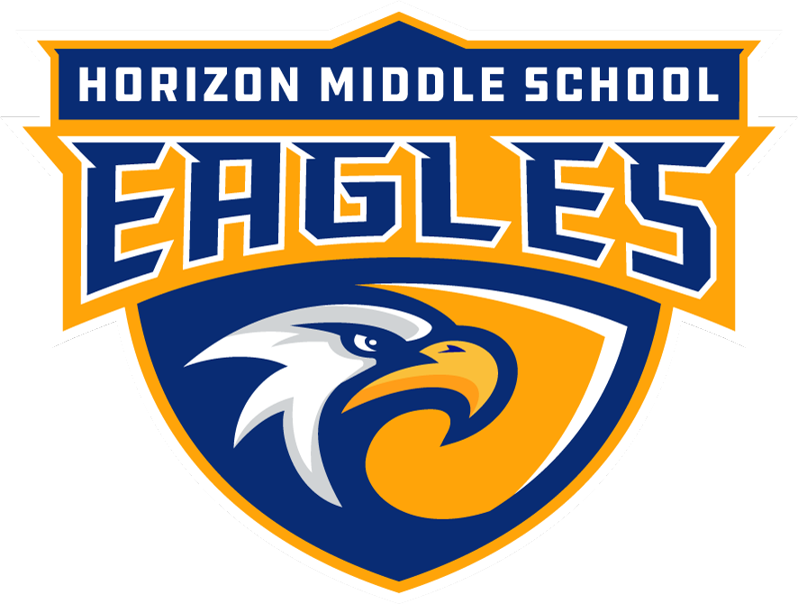
2022-2023
Bell Schedule
Teacher Hours – 8:55 – 4:25
M, T, R, F (44-45 Minute Periods) |  | Wednesday (41-Min Periods)
HOMEROOM | 9:10 – 9:20  Announcements 9:17-9:20 | HOMEROOM | 9:10 – 9:20  Announcements 9:17-9:20
PERIOD 1 | 9:20-10:05 | PERIOD 1 | 9:20 – 10:01
PERIOD 2 | 10:09 – 10:53 | PERIOD 2 | 10:05 – 10:46
W.I.N.G.S.  What I Need to Grow & Succeed | 10:57 – 11:27 |  | NO WINGS
PERIOD 3  LUNCH | 11:31 – 12:15 | PERIOD 3  LUNCH | 10:50 – 11:31
PERIOD 4  LUNCH | 12:19 – 1:03 | PERIOD 4  LUNCH | 11:35 – 12:16
PERIOD 5  LUNCH | 1:07 – 1:51 | PERIOD 5  LUNCH | 12:20 – 1:01
PERIOD 6  LUNCH | 1:55 – 2:39 | PERIOD 6  LUNCH | 1:05 – 1:46
PERIOD 7 | 2:43 – 3:27 | PERIOD 7 | 1:50 – 2:31
PERIOD 8  Announcements & Dismissal  4:16 – 4:20 | 3:31 – 4:16 | PERIOD 8  Announcements & Dismissal  4:16 – 4:20 | 2:35 – 3:16

